**Linux Commands:**

**______________________________________________________________________________**

1. **sudo su**

* **sudo**: It allows you to run commands as another user (usually the superuser or "root").
* **su**: This stands for "substitute user" and switches you to another user account (again, usually "root").

When you combine them:

* **sudo su**: This command gives you root (administrator) access by switching to the root user. It’s like saying, “Let me temporarily become the superuser so I can do anything on the system.”

C:\Users\DELL\OneDrive\Pictures\Screenshots\Screenshot 2024-09-18 114637.png

1. **mkdir, ls & cd**

* The **mkdir** command in Linux is used to create a new directory (Folder).
* The **ls** command is used to **list out** the files in a particular directory.
* The **cd** command is used to **change the working directory**.

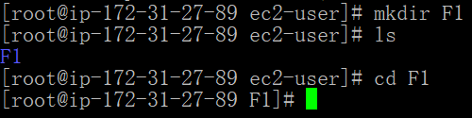

1. **vi & cat**

* The vi command is used to open the **Vi** text editor in Linux and Unix-like systems. Vi (short for **VIsual editor**) is a powerful, command-line text editor that allows users to create and edit text files directly from the terminal.
* **Vi <file_name>** => This opens the file named filename in the Vi editor. If the file doesn’t exist, it will create a new one.
* **Cat < file_name>** => This will print the contents of filename to the terminal.

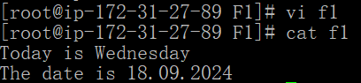

1. **wget**

* The **wget** command is anetwork utilityin Linux used to **download files from the web via** HTTP, HTTPS, and FTP protocols**.**
* **wget <URL>** => This will download the file from the given URL and save it in the current directory.

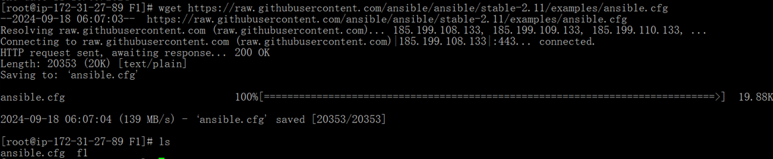

**______________________________________________________________________________**

1. **cp & mv**

* The cp and mv commands in Linux are used for copying and moving files and directories, respectively.
* cp <sorce> <destination> => This copies the file or directory from source to destination.

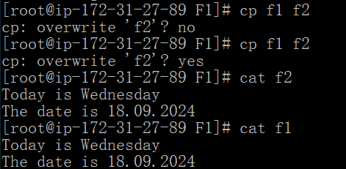

* mv <sorce> <destination> => This moves or renames source to destination.

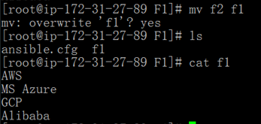

* If we use **cp ,** then the selected file will reflect in both source and destination fileds while using **mv** will not reflect the selected file in the source location.

__________________________________________________________________________________

1. **rm**

* The rm command in Linux is used to **remove (delete) files or directories**.
* rm <file-name> => This deletes the particular file.
* We can remove multiple files or directories in same time [ rm <f1> <f2> <f3> ]

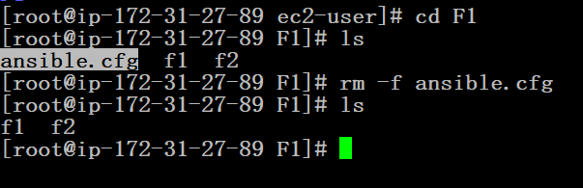

1. **rm –r**

* The rm -r command is used to **recursively delete directories and their contents** in Linux. The -r (or --recursive) option ensures that not only the specified directory is deleted, but also all files and subdirectories within it.

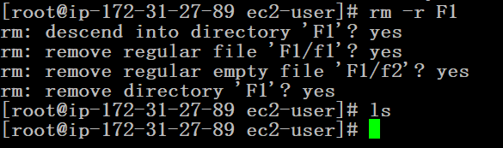

1. **Touch**

* The **touch** command used to **create an empty files**
* **touch <file-name>** => This creates an empty file with the given name

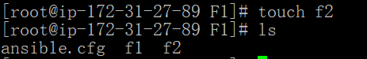

1. **ssh-keygen**

* The ssh-keygen command is used to generate **SSH (Secure Shell) key pairs**.

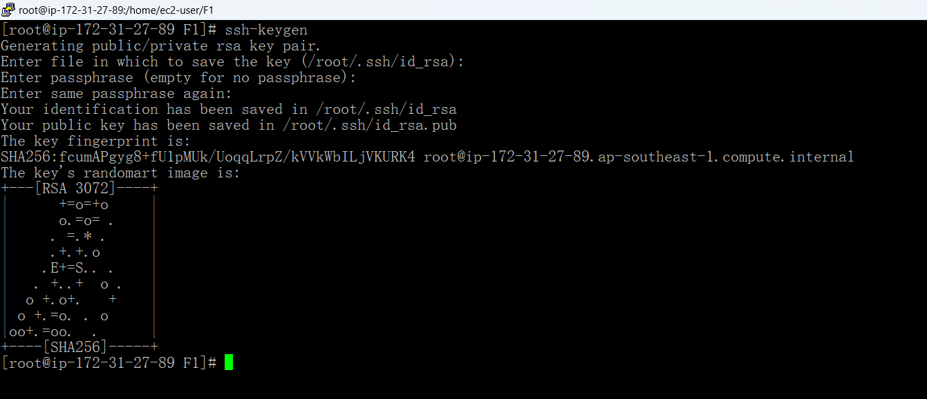

1. **history**

* The **history** command in Linux **displays a list of previously executed commands** in the terminal session.

